**“PROMTUCS GARNAGEE JACKSON, RESUME, 2020”**

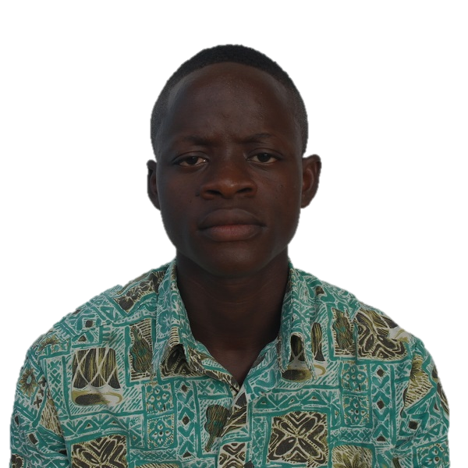**PERSONAL DATA**

Address : 1501 Community, Johnsonville Old Field  
 Barnersville Township  
 Montserrado County, Liberia

Sex : Male

Date of Birth : October 3, 1998

Place of Birth : Montserrado County,   
 Republic of Liberia

Marital Status : Single

Nationality : Liberian

Religion : Christianity

Contact Numbers : **+231 770025671/+231 777777674**  
Email Addresses : [**promtucsjackson1998@gmail.com**](mailto:promtucsjackson1998@gmail.com)[**jpromtucs@yahoo.com**](mailto:jpromtucs@yahoo.com)/**promtucs.jackson@orange.com**

**OBJECTIVE**: Provide dedicated and advance services to client on a timely basis.

**EDUCATIONAL BACKGROUND**

|  |  |  |
| --- | --- | --- |
| **Years** | **Institution(s) or Organization(s)** | **Achievements** |
| April 22, 2019 – Present | Udemy Online Course | **Certificate in Web Development**  Building Professional Websites |
| August 4-8, 2019 | WITBE Quality of Experience | **Certificate in WITBE Robot Web and Mobile Technologies Management Training**  › Creating value for Media customers.  › WITBE architecture principles: Maestro, Workbench, Robots, Portal.  › Developing and managing test cases on Mobile Applications & Media Players with WITBE Workbench.  › Developing Dashboards on Data lab & create value |
| 2015-2019 | BlueCrest University College, Liberia | Bachelor of Science **(B.Sc.)** in **Information Technology (IT)** with emphasis in **Network Engineering**. |
| 2017 | Solo Learn | **Certificate in Java Programming**  Java Programming Basics like several Arithmetic and Logical Programming. |
| 2012-2015 | Sister Shirley Kolmer Memorial Catholic School | **High School Diploma and W.A.E.C. Certificate** |

**CULTURAL COMPETENCES**

* Excellent Communication skills;
* Very fast thinker and mover;
* Good problem solving and analytical skills;
* Good interpersonal relation;
* Self-motivated team player with a proactive approach to work;
* Ability to work under pressure to meet strict deadlines with limited or no supervision;
* Good leadership skills;
* I have the flexibility, adaptability and wiliness needed to learn new skills;

**WORK EXPERIENCES**

|  |  |  |
| --- | --- | --- |
| **Year (s)** | **Institutions or Organization(s)** | **Position/Duties** |
| January 2, 2020-Present | Orange Liberia | **NSS Engineer**  **Duties**:   * Monitor various Orange Liberia 2G, 3G, 4G, LTE and TDD sites for any breakdowns through our EMS Servers in order for it to be resolve as soon as possible. * Monitor the Network for efficient traffic flow. * Monitor our Billing Servers (IN Platform) to make sure that it is not charging more than it should. * I monitor IPs of our various ISP Customers to make sure that there is no packet loss in their IP. * I also monitor various Services that are rendered to some customers to make sure that the services stay up. * I monitor our MSC (Mobile Switching Center) and generate KPIs hourly in order to improve the availability of our Services rendered to customers. |
| July 7, 2019-January 2, 2020 | Orange Liberia | **NSS Technician (Intern)**  **Duties**:   * Monitor various Orange Liberia 2G, 3G, 4G, LTE and TDD sites for any breakdowns through our EMS Servers in order for it to be resolve as soon as possible. * Monitor the Network for efficient traffic flow. * Monitor our Billing Servers to make sure that it is not charging more than it should. * I monitor IPs of our various ISP Customers to make sure that there is no packet loss in their IP. * I also monitor various Services that are rendered to some customers to make sure that the services stay up. * I monitor our MSC (Mobile Switching Center) and generate KPIs hourly in order to improve the availability of our Services rendered to customers. |
| 2014-2019 | Favored Innovation Business Bend and Stop, Barnesville Township, Montserrado County, Liberia | **Data Entry Clerk**  **Duties**:  Do speedy and accurate commercial typing at least 55 WPM, design invitations, wedding/program souvenirs, etc.  Do some registrations online like WAEC, Facebook, Gmail, Yahoo mail etc.  Troubleshoot the Internet for fast browsing possibility in order to satisfy the needs of our customers. |

**OTHER ACHIEVEMENTS**

|  |  |  |
| --- | --- | --- |
| **Date** | **Institution or Organization** | **Achievement** |
| August 21, 2019 | ZTE | * Training on the differences between 2G, 3G, 4G and LTE. * How to generate various kinds of reports from the EMS. |
| December 15-16, 2017 | International Conference on Advanced Trends in ICT and Management hosted by BlueCrest University College at the Centennial Pavilion | **Certificate of Participation** |

**REFERENCES:**

Mr. Kamal Hiran

**Head of IT Department**BlueCrest University, Liberia

Tel: **+231778805255**

[Kamal.hiran@bluecrestcollege.com](mailto:Kamal.hiran@bluecrestcollege.com)

Thomas Richard Walker

**Technical Manager**

Favored Innovation Business

Tel: **+231770244714/+231886800523**

[favoredbusinessinc@gmail.com](mailto:favoredbusinessinc@gmail.com)

Dixon Morris

**NSS Supervisor**

Orange Liberia

Tel: **+231777777133**[morris.dixon@orange.com](mailto:morris.dixon@orange.com)